**Ligen Lin**

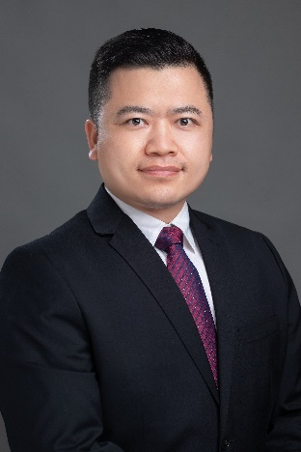State Key Laboratory of Quality Research in Chinese Medicine  
Institute of Chinese Medical Sciences, University of Macau

Tel.: +853 88228041; email: [ligenl@um.edu.mo](mailto:ligenl@um.edu.mo);

address: Room 6044, Research building N22,

Avenida da Universidade, Taipa, Macao, China.

Personal website: https://sklqrcm.um.edu.mo/li-gen-lin/

**Education**

Ph.D. 2002-2007 Shanghai Institute of Materia Medica, Chinese Academy of Sciences, Shanghai, Majority: medicinal chemistry

B.E. 1998-2002 Zhejiang University, Zhejiang, Majority: pharmaceutical engineering

**Experience**

2021.4-now, Associate head of the Department of Pharmaceutical Science, Faculty of Health Sciences, University of Macau, Macao, China

2019.8-now, Associate Professor, Institute of Chinese Medical Sciences, University of Macau, Macao, China

2013.4-now, PhD supervisor, Institute of Chinese Medical Sciences, University of Macau, Macao, China.

2013.4-2019.8, Assistant Professor, Institute of Chinese Medical Sciences, University of Macau, Macao, China.

2008.1-2013.1, Postdoctoral Associate, Children’s Nutrition Research Center, Department of Pediatrics, Baylor College of Medicine, Houston, USA.

2007.7-2008.1, Assistant Professor, Shanghai Institute of Materia Medica, Chinese Academy of Sciences, Shanghai, China.

**Areas of expertise**

1. Natural products chemistry, development of new methods in isolation, structure elucidation, and target identification of bioactive natural products.

B. Screening of novel lead compounds for treatment of obesity, diabetes and aging

C. Mechanism study for diet-related metabolic disorders.

**Achievements and Awards**

Dr. Lin has published 170+ research papers in peer-reviewed journals, including Nature Communications, Cell Death & Differentiation, Journal of Cachexia, Sarcopenia and Muscle, Diabetes, Acta Pharmaceutica Sinica B, and British Journal of Pharmacology. As the principle investigator, he has been awarded 17 research grants, with the total funding about 17.2 million. He was awarded the Youth Researcher Prize in Shanghai Pharmaceutical Association, the Progress Award in Medicine of Shanghai Municipality, the Keystone Symposia scholarship, the Best Teacher Award of ICMS. He has filed 6 China patents and 1 USA patent, and published 3 book chapters. Additionally, he has successfully developed several health products.