CURRICULUM VITAE
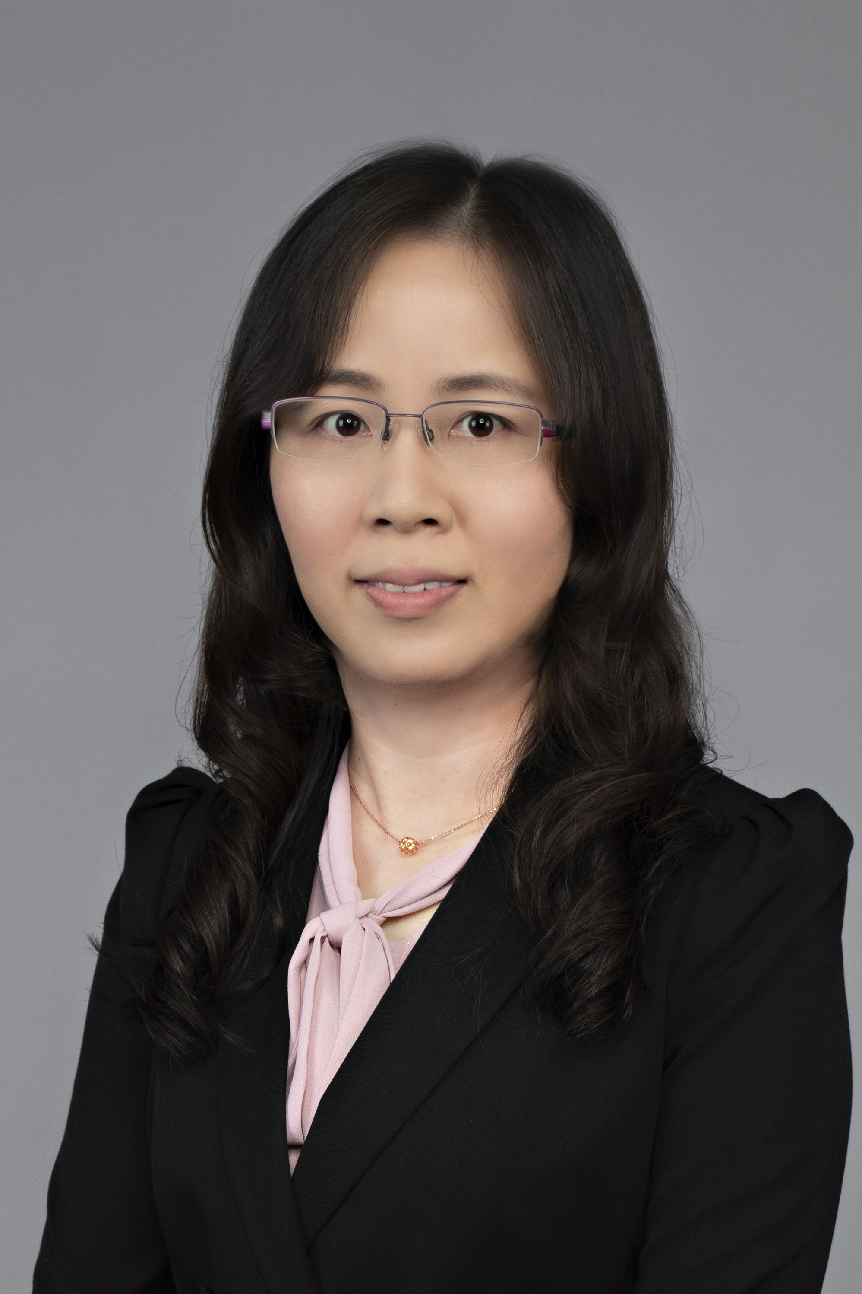
Meiwan Chen, Professor,
Institute of Chinese Medical Sciences, University of Macau
E-mail: mwchen@um.edu.mo, https://sklqrcm.um.edu.mo/mei-wan-chen/

Professional Highlights
Prof. Meiwan Chen’s research focuses on biomaterial and nanomedicine, especially on development of novel drug delivery systems for active ingredients of Chinese medicine. The research ranges from design and synthesis of novel lipidic and polymeric carriers to mechanistic understanding of delivery barriers and to in vivo studies of relevant tumor models and rheumatoid arthritis. The emphasis is on improving the efficacy of chemotherapeutics that have poor water-solubility, fast metabolism, non-selectivity, and drug resistance. Leveraging on the expertise and resources of the SKL of Quality Research in Chinese Medicine at the University of Macau, the lab also develops nanomedicines combining Chinese and Western medicinal compounds for synergistic effects.
Prof. Chen has published 117 top-tier SCI journals (25 papers with IF>10, 78 papers with IF>5) as the first/corresponding author, including Advanced Materials, ACS Nano, Nano Letters, Biomaterials, and many more. Her publications have been cited >10000 times, with an h-index of 57, with 5 being recognized internationally as “ESI highly cited papers”. She has been in charge 20 projects funded by NSFC as well as the Macau Fund. She also published 6 book chapters and 9 patents. She was awarded the Excellent Young Scientist Fund by National Natural Science Foundation of China in 2019 (the first time opened for HK and Macao applicants) and ‘Qi Huang’ Youth Scholarship by the State Administration of TCM, China in 2020. She was elected as a Fellow of the Royal Society of Chemistry (FRSC) in 2022. She won the Natural Science Award (2nd/2nd/3rd Class) in 2012/2014/2018 and the Science and Technology Progress Award (3rd Class) in 2022, as awarded by the Macao Science and Technology Award.
She (co-)supervises more than 30 PhD/MSc graduates: one student received the second prizes in the ‘Challenge Cup’ national inter-varsity competition for extracurricular academic technological projects in 2022; one graduate ranked first under Young Elite Scientist Sponsorship Programme; one student received the 9th China Youth Science and Technology Innovation Award; seven students received the Macao Science and Technology Award-Scientific and Technological R&D Awards for Postgraduates; and more than thirty conference awards.
She also actively participated in internal services (faculty and college) and external services (academic and community). Her professional services are exceptional with great visibility in the community.
The above achievements have also led to numerous professional honors/awards, including:
- Fellow of the Royal Society of Chemistry (FRSC), UK, 2022.05
- ‘Qi Huang’ Youth Scholarship by National Administration of Traditional Chinese Medicine, China in 2020.12
- Excellent Young Scientist Fund by National Natural Science Foundation of China in 2019.10
- Science and Technology Progress Award (Third Prize) in the fifth Macao Science and Technology Awards in 2022
- Natural Science Award (2nd/2nd/3rd Class) in the first/second/fourth Macao Science and Technology Award in 2012/2014/2018
- ICMS Academic Award from UM (2019/2020, 2017/2018)
- Incentive Award Scheme for Outstanding Academic Staff from UM (2016/2017)
- the world's top 2% scientists in 2020 released by Stanford University
(https://elsevier.digitalcommonsdata.com/datasets/btchxktzyw/3).

Selected Publications (*corresponding and co-corresponding author)
- P Hua†, D Jiang†, ZP Guo†, HY Tian, XS Chen, MW Chen*. Amplified cancer immunotherapy of PD-L1 blockade by sequential tumor microenvironment reshaping and DC maturation. Chemical Engineering Journal, 2023, 453: 139795. (IF: 16.744)
- X Wang, P Hua, CW He, MW Chen*. Non-apoptotic cell death-based cancer therapy: Molecular mechanism, pharmacological modulators, and nanomedicine. Acta Pharmaceutica Sinica B, 2022, 12(9), 3567-3593 (IF: 14.907)
- MY Zhao, HJ Zhuang, HX Zhang, BH Li, J Ming, XY Chen*, MW Chen*. A LRET Nanoplatform Consisting of Lanthanide and Amorphous Manganese Oxide for NIR-II Luminescence Lifetime Imaging of Tumor Redox Status. Angewandte Chemie International Edition, 2022, e202209592 (IF: 16.823)
- GJ Song, D Jiang, JC Wu, XZ Sun, MY Deng, L Wang, CX Hao, JY Shi, HT Liu, YQ Tian*, MW Chen*. An ultrasensitive fluorescent breath ammonia sensor for noninvasive diagnosis of chronic kidney disease and helicobacter pylori infection. Chemical Engineering Journal, 2022, 440: 135979. (IF: 16.744)
- ZJ Yang, DL Tao, WZ Zhong, Z Liu, LZ Feng*, MW Chen*. Perfluorocarbon loaded fluorinated covalent organic polymers with effective sonosensitization and tumor hypoxia relief enable synergistic sonodynamic-immunotherapy. Biomaterials, 2022, 280: 121250. (IF: 15.304)
- WZ Zhong, KH Wong, FJ Xu, NN Zhao, MW Chen*. NIR-responsive polydopamine-based calcium carbonate hybrid nanoparticles delivering artesunate for cancer chemo-photothermal therapy. Acta Biomaterialia, 2022, 145, 135-145 (IF: 10.633)
- SLX Yang†, KH Wong†, P Hua†, CW He, H Yu, D Shao, Z Shi, MW Chen*. ROS-responsive fluorinated polyethyleneimine vector to co-deliver shMTHFD2 and shGPX4 plasmids induces ferroptosis and apoptosis for cancer therapy. Acta Biomaterialia, 2022, 140, 492-505. (IF: 10.633)
- KH Wong†, DL Yang†, SS Chen†, CW He, MW Chen*. Development of nanoscale drug delivery systems of dihydroartemisinin for cancer therapy: A review. Asian Journal of Pharmaceutical Sciences, 2022, 17(4), 475-490. (IF: 9.298)
- RF Liang†, KH Wong†, Y Yang*, YR Duan, MW Chen*. ROS-responsive dexamethasone micelles normalize the tumor microenvironment enhancing hypericin in cancer photodynamic therapy. Biomaterials Science, 2022, 10, 1018-1025. (IF: 7.590)
- ZA Wang†, X Wang†, H Yu, MW Chen*. Glioma-targeted multifunctional nanoparticles to co-deliver camptothecin and curcumin for enhanced chemo-immunotherapy. Biomaterials Science, 2022, 10, 1292-1303. (IF: 7.590)
- GJ Song†, D Jiang†, L Wang, XZ Sun, HT Liu, YQ Tian*, MW Chen*. A series of simple curcumin-derived colorimetric and fluorescent probes for ratiometric-pH sensing and cell imaging. Chinese Chemical Letters, 2022, 33(1), 339-343. (IF: 8.455)
- ZP Guo, YY Hu, MY Zhao, K Hao, P He, HY Tian, XS Chen, MW Chen*. Prodrug-Based Versatile Nanomedicine with Simultaneous Physical and Physiological Tumor Penetration for Enhanced Cancer Chemo-Immunotherapy. Nano Letters, 2021, 21(9), 3721-3730. (IF: 12.262)
- ZA Wang†, X Wang†, JB Wan, FJ Xu, NN Zhao, MW Chen*. Optical Imaging in the Second Near Infrared Window for Vascular Bioimaging. Small, 2021, 17(43): 2103780. (IF: 15.153)
- CJ Wang, C Liang, Y Hao, ZL Dong, YJ Zhu, QG Li, Z Liu, LZ Feng*, MW Chen*. Photodynamic creation of artificial tumor microenvironments to collectively facilitate hypoxia-activated chemotherapy delivered by coagulation-targeting liposomes. Chemical Engineering Journal, 2021, 414: 128731. (IF: 16.744)
- QQ Guo, Y Dong, YH Zhang, H Fu, CR Chen, LT Wang, XP Yang, M Shen, J Yu, MW Chen*, JL Zhang*, YR Duan*. Sequential Release of Pooled siRNAs and Paclitaxel by Aptamer-Functionalized Shell–Core Nanoparticles to Overcome Paclitaxel Resistance of Prostate Cancer. ACS Applied Materials & Interfaces, 2021, 13(12): 13990-14003. (IF: 10.383)
- QG Li, ZL Dong, MW Chen*, LZ Feng*. Phenolic molecules constructed nanomedicine for innovative cancer treatment. Coordination Chemistry Reviews, 2021, 439: 213912. (IF: 24.833)
- Y Yang, WJ Zhu, L Cheng, R Cai, X Yi, JX He, XS Pan, L Yang, K Yang, Z Liu, WH Tan*, MW Chen*. Tumor microenvironment (TME)-activatable circular aptamer-PEG as an effective hierarchical-targeting molecular medicine for photodynamic therapy. Biomaterials, 2020, 246: 119971. (IF: 15.304)
- Y Yang†, JX He†, WJ Zhu, XS Pan, H.S. Yazd, C Cui, L Yang, XW Li, L Li, L Cheng, LZ Feng, RW Wang, Z Liu*, MW Chen*, WH Tan*. Molecular domino reactor built by automated modular synthesis for cancer treatment. Theranostics, 2020, 10(9): 4030-4041. (IF: 11.600)
- ZP Guo, L Lin, K Hao, DW Wang, F Liu, PJ Sun, HY Yu, ZH Tang, MW Chen*, HY Tian*, XS Chen. Helix Self-Assembly Behavior of Amino Acid-Modified Camptothecin Prodrugs and Its Antitumor Effect. ACS Applied Materials & Interfaces, 2020, 12(6): 7466-7476. (IF: 10.383)
- GJ Song, D Jiang, L Wang, JW Ning, XZ Sun, FY Su*, MW Chen*, YQ Tian*. A mitochondria-targeting NIR fluorescent potassium ion sensor: real-time investigation of the mitochondrial K⁺ regulation of apoptosis in situ. Chemical Communications, 2020, 56(40): 5405-5408. (IF: 6.065)
- MW Chen*, XZ Zhou, RE Chen, JL Wang, R D. Ye, YT Wang, CB Wu, R I. Mahato. Nano-carriers for delivery and targeting of active ingredients of Chinese medicine for hepatocellular carcinoma therapy. Materials Today, 2019, 25: 66-87. (IF: 26.943)
- TT Pan, C Yang, JY Shi, CX Hao, Y Qiao, JZ Li, MY Deng, YQ Tian*, MW Chen*. Dual pH and oxygen luminescent nanoprobes based on graft polymers for extracellular metabolism monitoring and intracellular imaging. Sensors and Actuators B: Chemical, 2019, 291: 306-318. (IF: 9.221)
- Y Yang, WJ Zhu, LZ Feng, Y Chao, X Yi, ZL Dong, K Yang, WH Tan, Z Liu*, MW Chen*. G-Quadruplex-Based Nanoscale Coordination Polymers to Modulate Tumor Hypoxia and Achieve Nuclear-Targeted Drug Delivery for Enhanced Photodynamic Therapy. Nano letters, 2018, 18 (11): 6867-6875. (IF: 12.262)
- Y Yang, LG Xu, WJ Zhu, LZ Feng, JJ Liu, Q Chen, ZL Dong, JY Zhao, Z Liu*, MW Chen*. One-pot synthesis of pH-responsive charge-switchable PEGylated nanoscale coordination polymers for improved cancer therapy. Biomaterials, 2018, 156: 121-133. (IF: 15.304)
- ZP Guo, L Lin, J Chen, XZ Zhou, HF Chan, XS Chen, HY Tian*, MW Chen*. Poly (ethylene glycol)-poly-L-glutamate complexed with polyethyleneimine-polyglycine for highly efficient gene delivery in vitro and in vivo. Biomaterials Science, 2018, 6(11): 3053-3062. (IF: 7.590)
- XJ Song, J Xu, C Liang, Y Chao, QT Jin, C Wang, MW Chen*, Z Liu*. Self-Supplied Tumor Oxygenation through Separated Liposomal Delivery of H₂O₂ and Catalase for Enhanced Radio-Immunotherapy of Cancer. Nano letters, 2018, 18 (10): 6360-6368. (IF: 12.262)
- JM Zhang†, JJ Li†, Z Shi, Y Yang, X Xie, SMY Lee*, YT Wang, KW Leong, MW Chen*. pH-sensitive polymeric nanoparticles for co-delivery of doxorubicin and curcumin to treat cancer via enhanced pro-apoptotic and anti-angiogenic activities. Acta Biomaterialia, 2017, 58: 349-364. (IF: 10.633)
- LZ Feng, DL Tao, ZL Dong, Q Chen, Y Chao, Z Liu*, MW Chen*. Near-infrared light activation of quenched liposomal Ce6 for synergistic cancer phototherapy with effective skin protection. Biomaterials, 2017, 127: 13-24. (IF: 15.304)
- Y Yang, WJ Zhu, ZL Dong, Y Chao, L Xu*, MW Chen*, Z Liu*. 1D Coordination Polymer Nanofibers for Low-Temperature Photothermal Therapy. Advanced Materials, 2017, 29(40): 1703588. (IF: 32.086)
- YE Cai, JM Zhang, NG. Chen, Z Shi, JG Qiu, CW He, MW Chen*. Recent Advances in Anticancer Activities and Drug Delivery Systems of Tannins. Medicinal Research Reviews, 2017, 37(4): 665-701. (IF: 12.388)

